Chapter 8, Problem 76.

Find the dual of the circuit in Fig. 8.120.

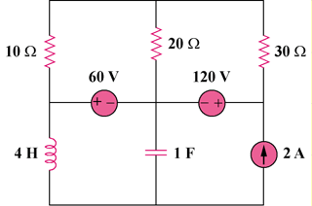

Figure 8.120
For Prob. 8.76.

